1. What is Convolution?
   1. What are the elements of a Convolution block



Image Resnet

Step 1 :

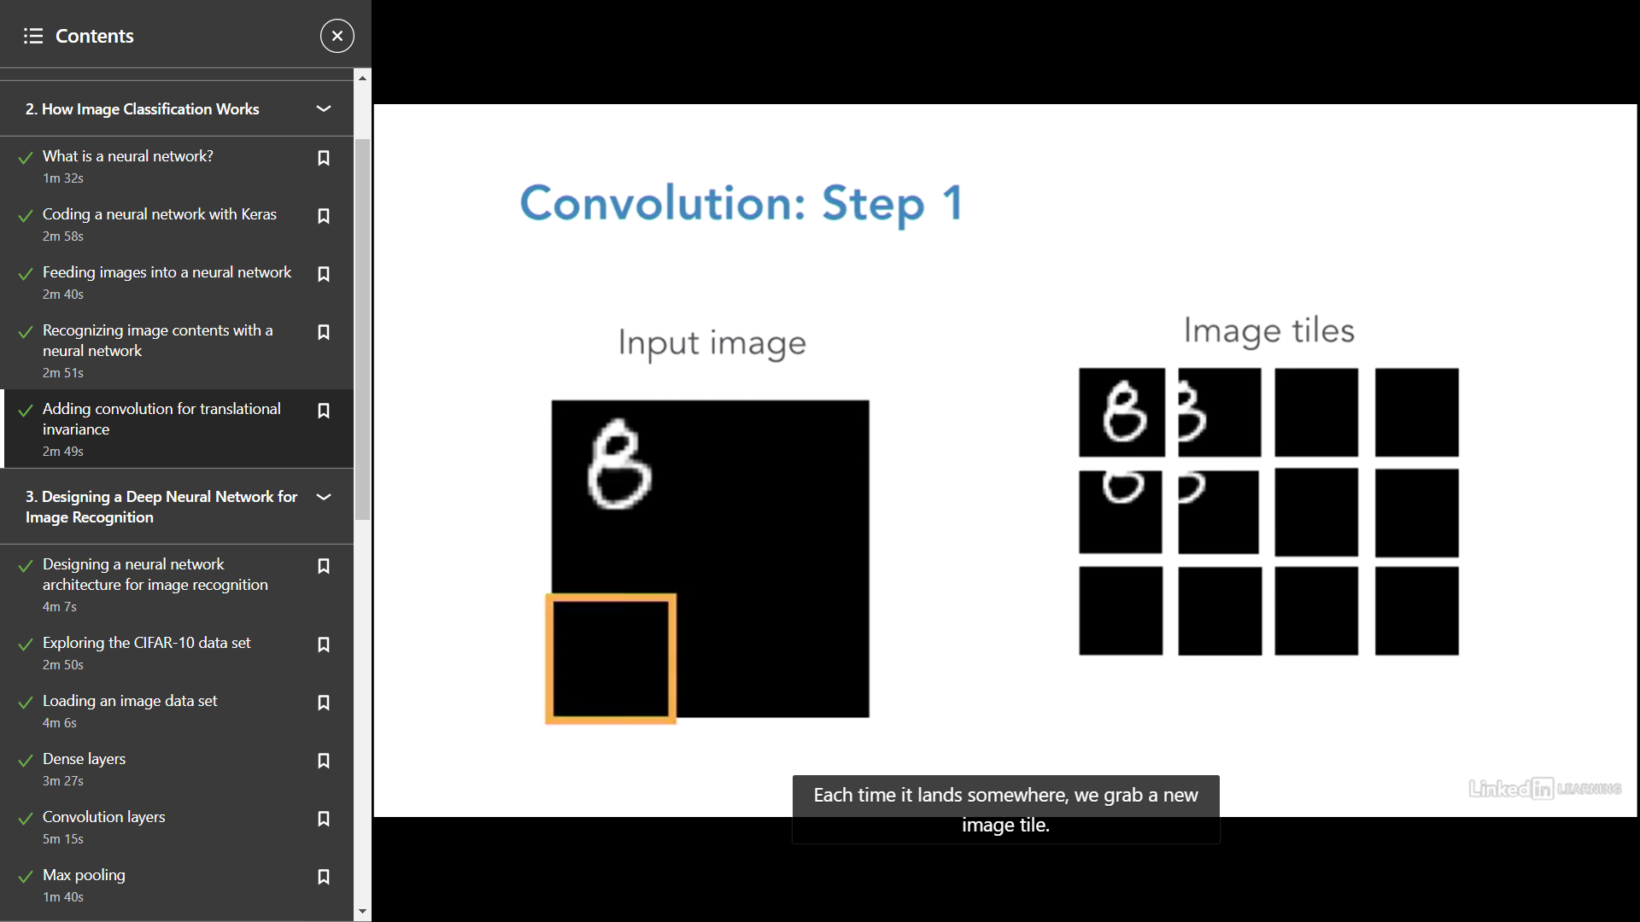

-- How can we apply convolutions to structured data

Customer | Jan|Feb|Mar|Apr|May|June 26, - july

A|P|NP|P…..

RNN + CNN

CNN + LSTM

CNN summarized :

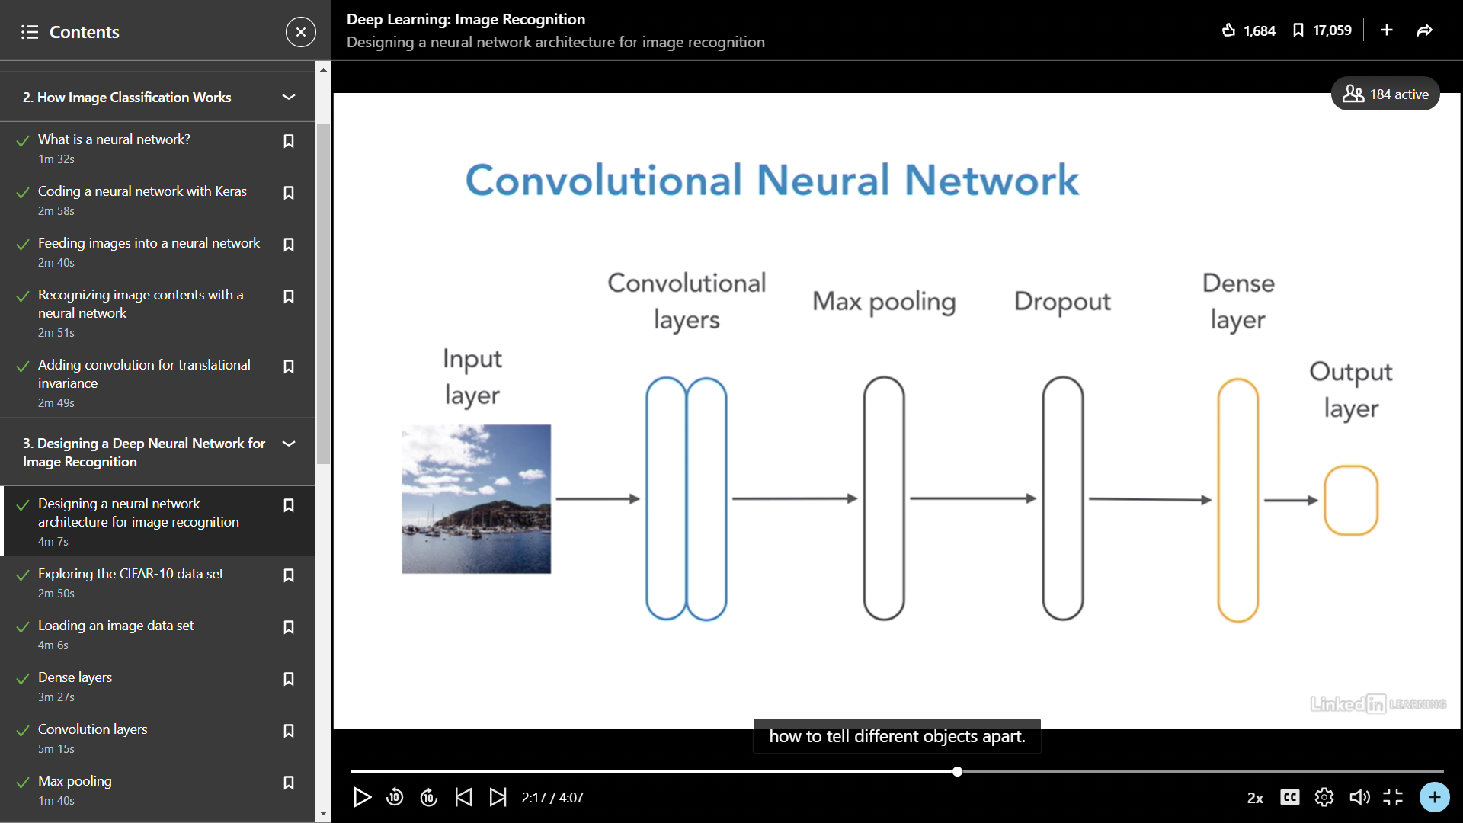

Max Pooling

Things for you to research :

What is Deep metric learning :

--- CNN vs RNN

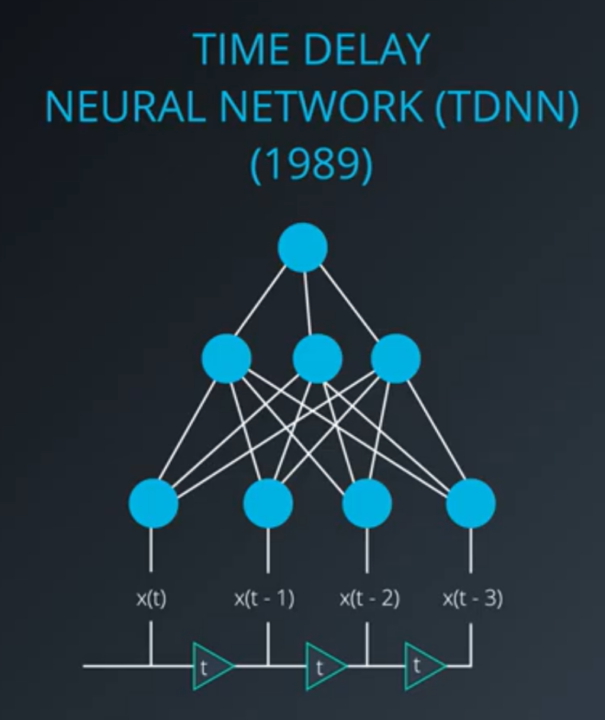

Pre requisites

Feed Forward- Start with random Weights -> Evaluate Output

Matrix multiplication of Weights and Inputs

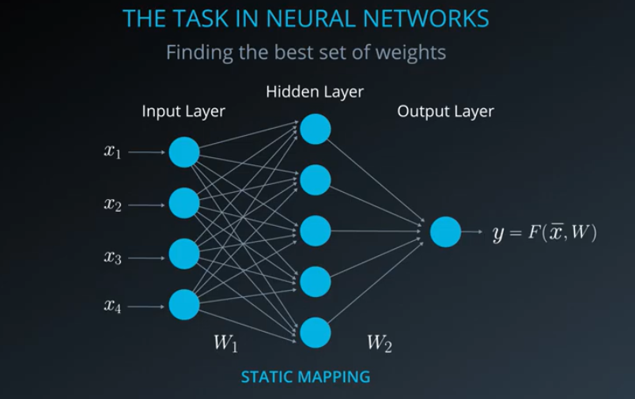

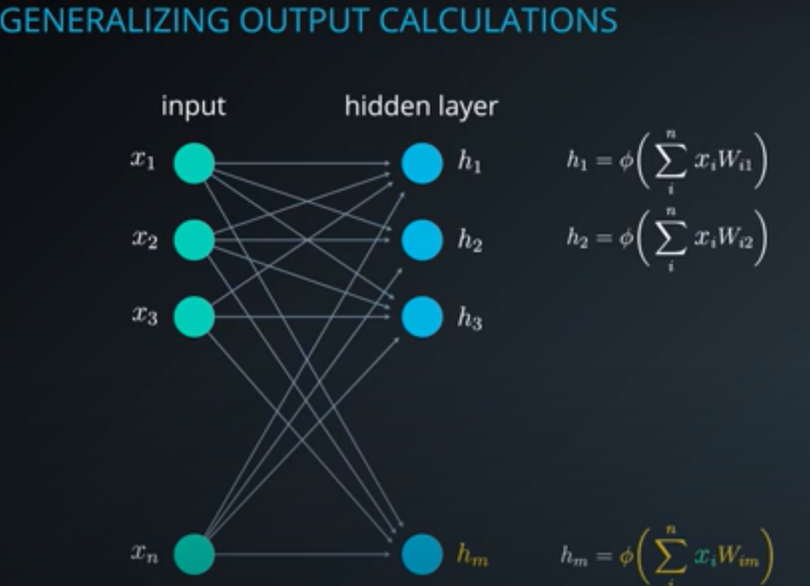

Understanding why do we need non linear activation functions

Sigmoid 0 : 1

Tanh : -1 : 1

ReLu

< 0 ->0

Input as it is

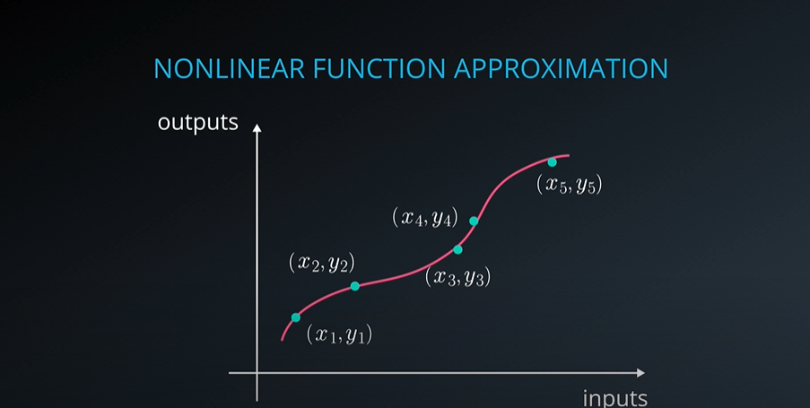

Back Propogation - Calculate change in Weights to reduce error in each step

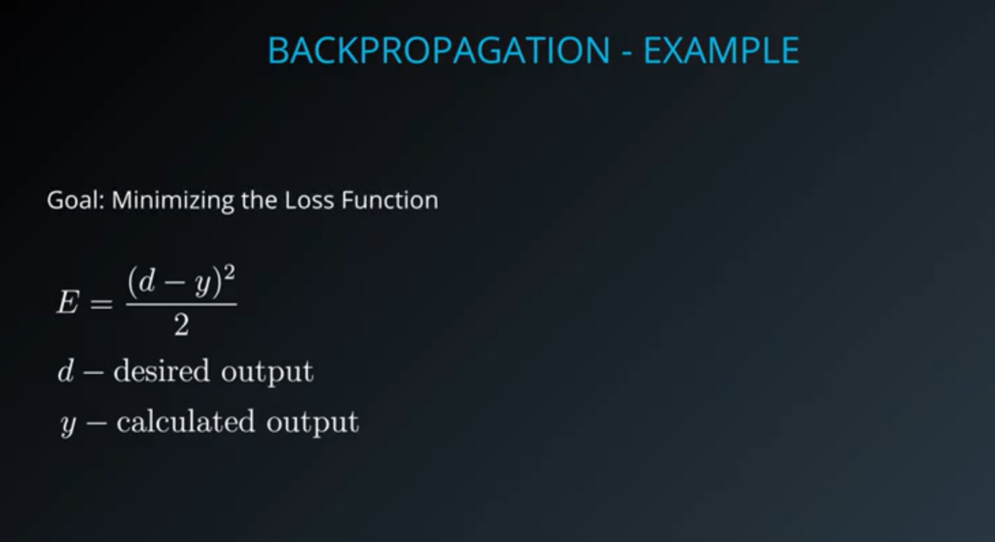

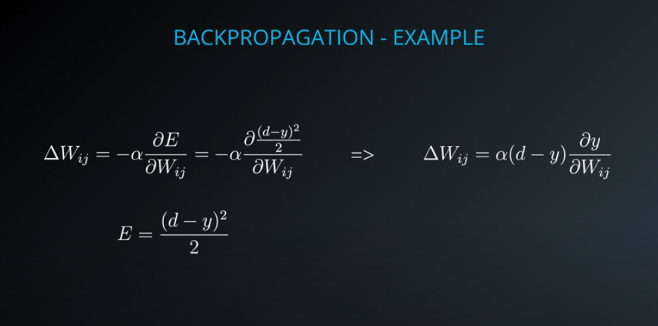

This is the RNN **folded model**:

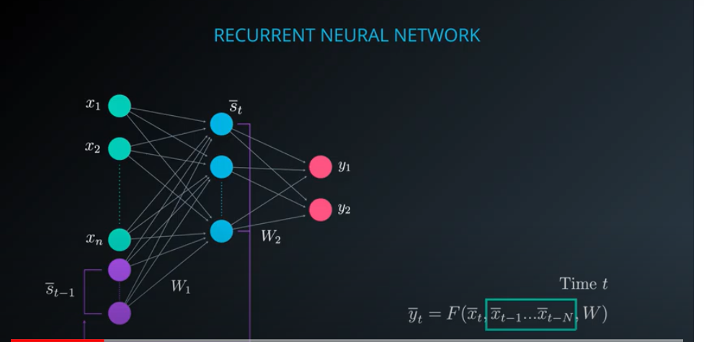

Unfolded Model

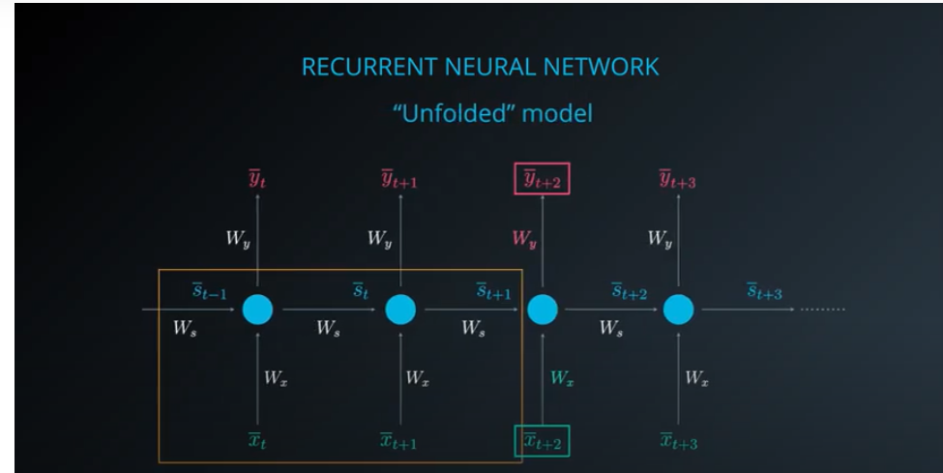

How does RNN remember

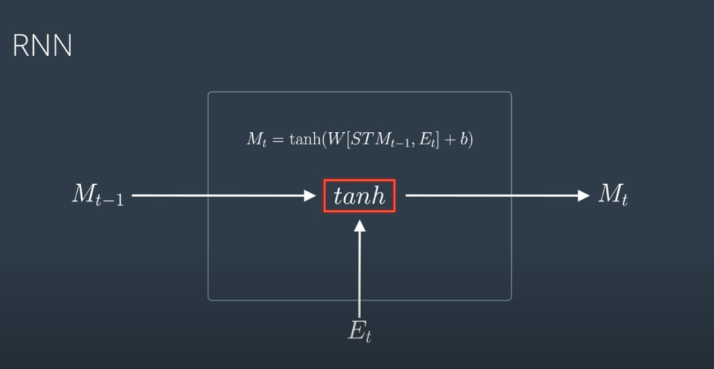

Need for LSTM

Vanishing Gradient problem

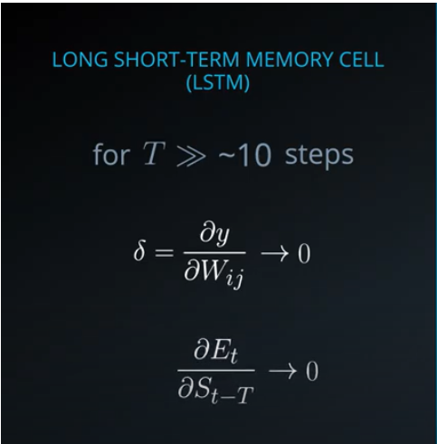

Output - Y

X -Input

H1 - Hidden Layer

H2

Y -> H2 -> H1 -> X

DY/H2 * H2/H1 *H1/X

Impact of Long term memory on RNN

Y -> Yt-1 -> Yt-2 -> Yt-3

RNN vs LSTM

Let’s say we

are watching a TV show

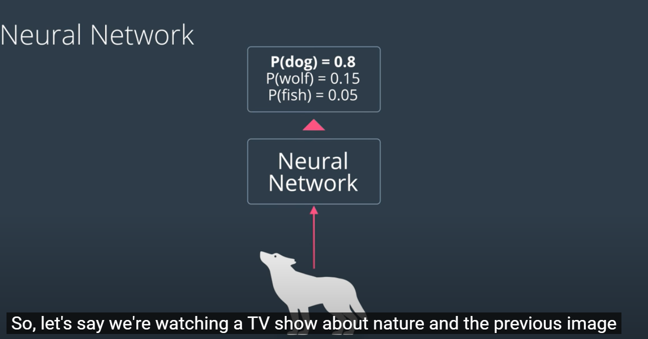

How can we be sure that the image is definitely a dog and not a wolf?

Say we allow information from previous outputs to flow in…

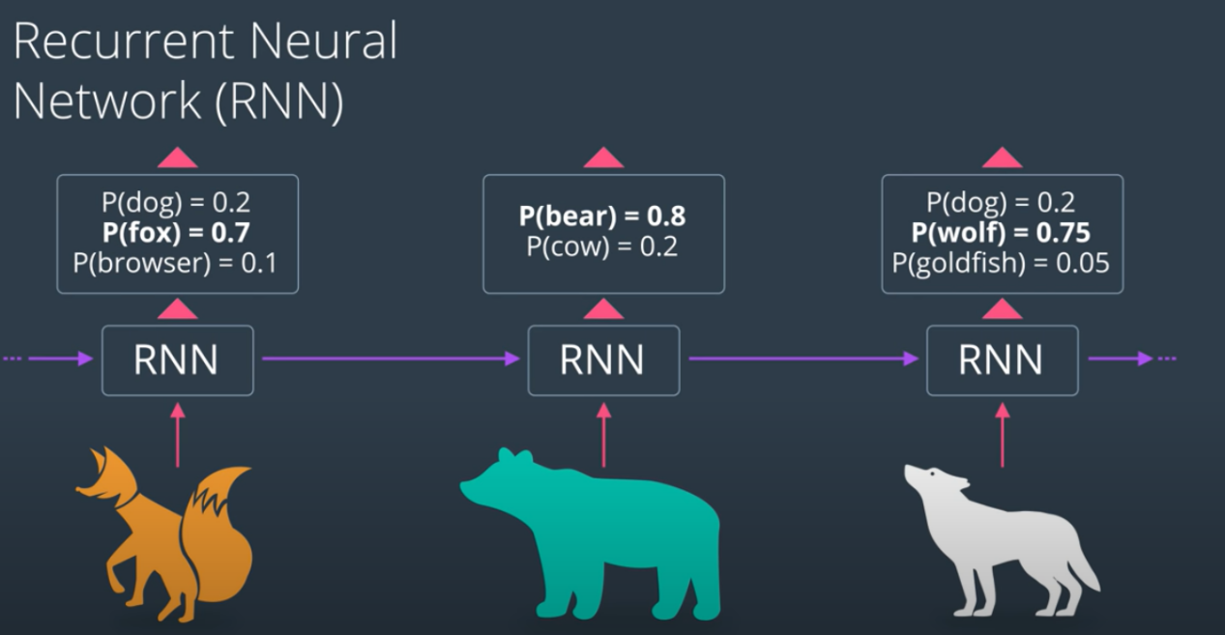

This RNN flow of information has some flaws.. What if bear appeared a few steps ago?

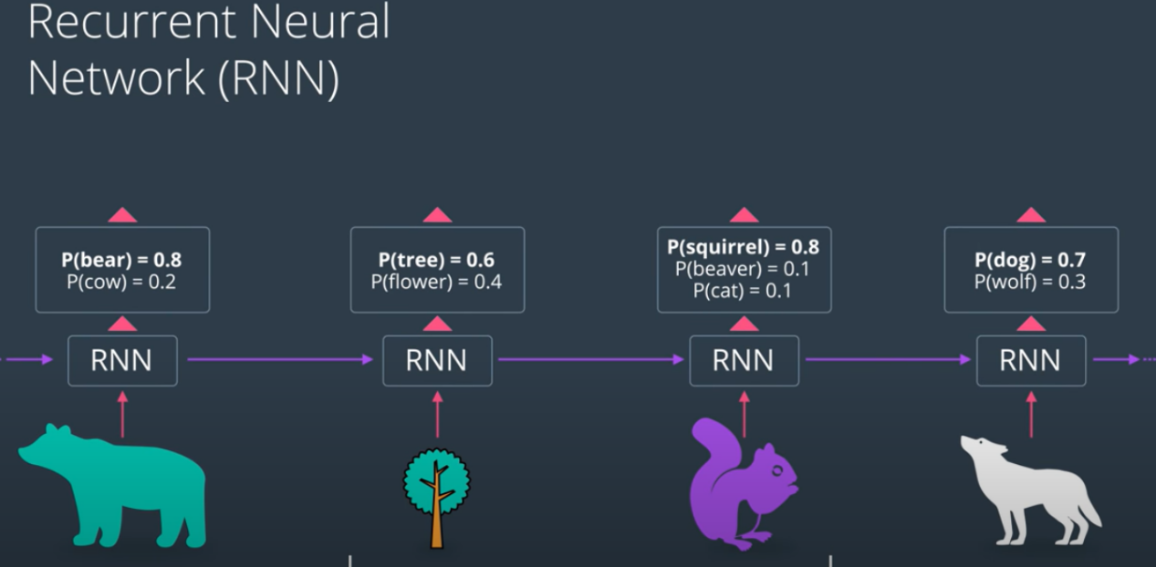

This is where a LSTM architecture helps

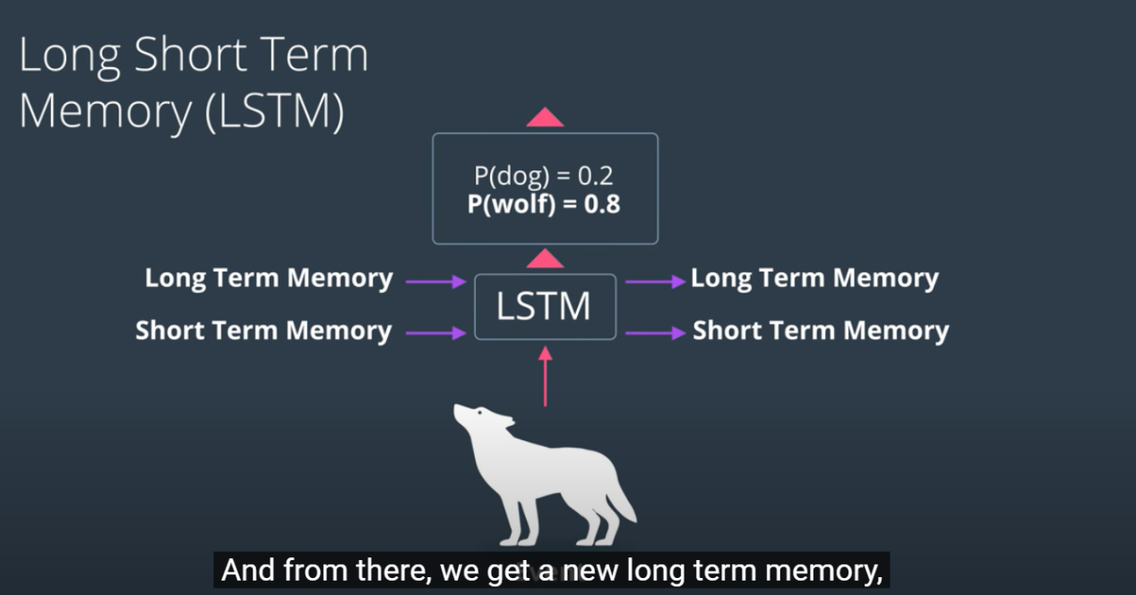

LSTM has an archtecture which updates, Long term and short term memory while using both to make a decision.. In this case:

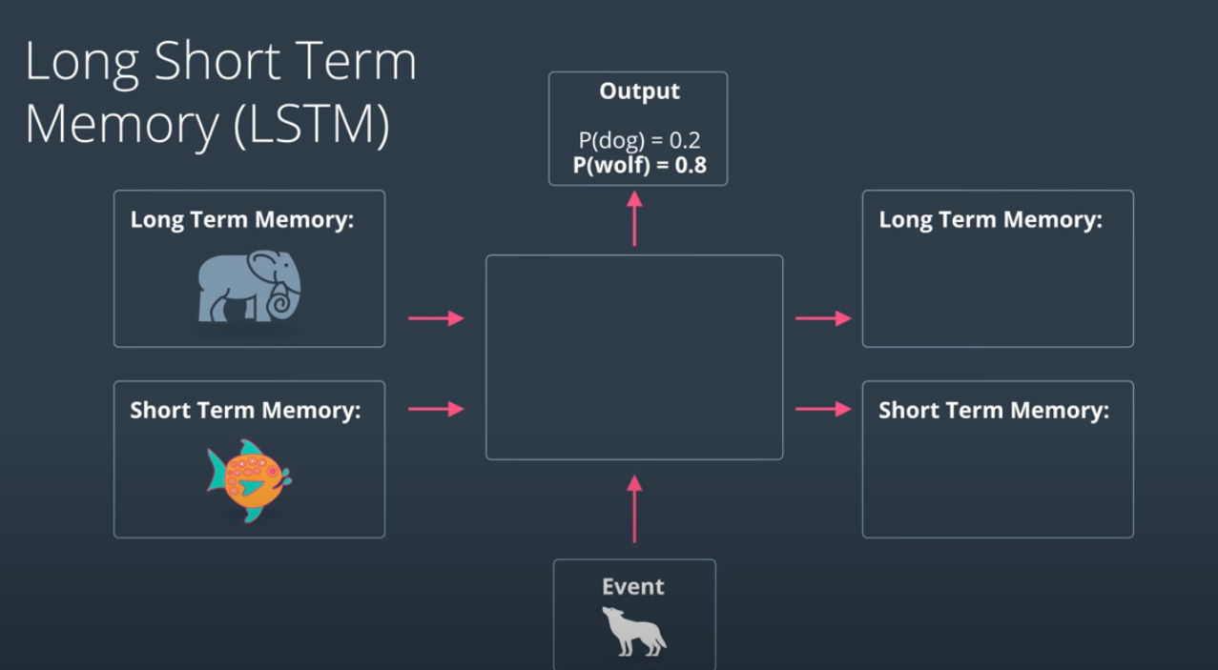`

This is how LSTM works

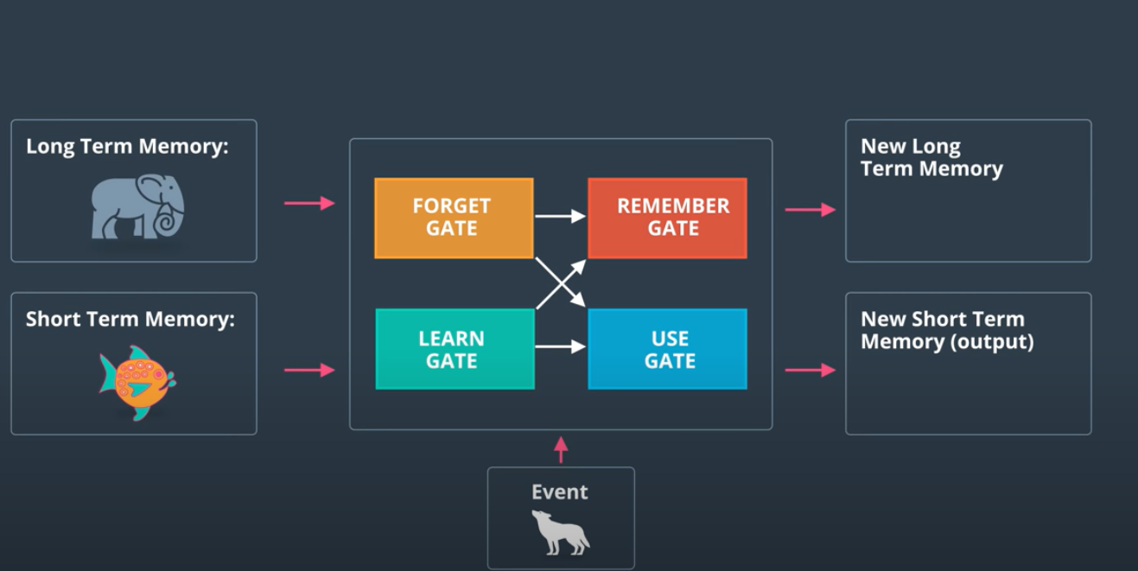

This is how these gates are updated

Step 1

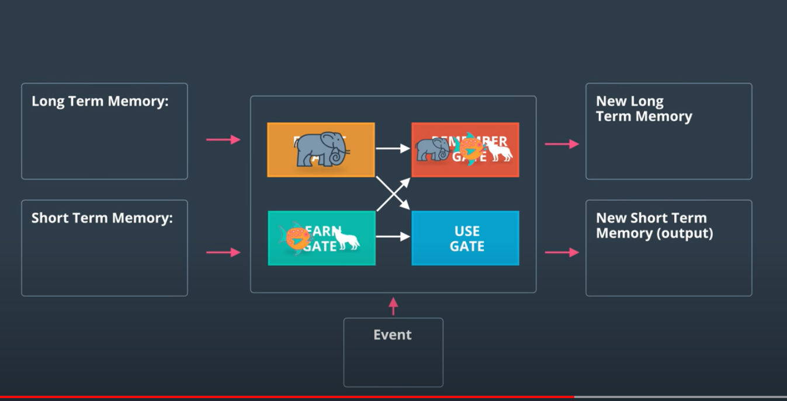

Step 2

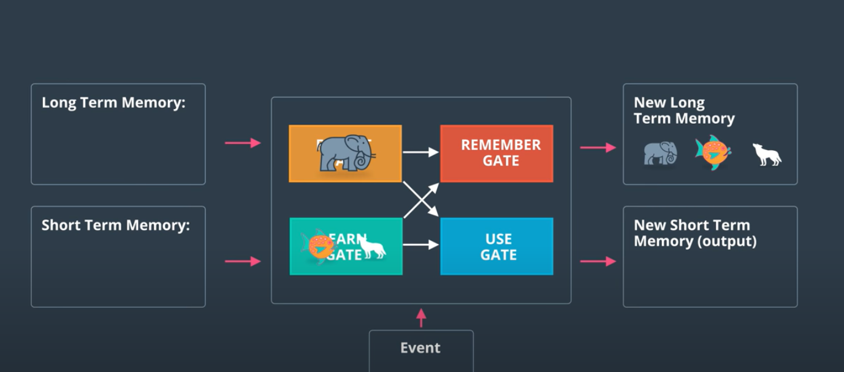

Step 3

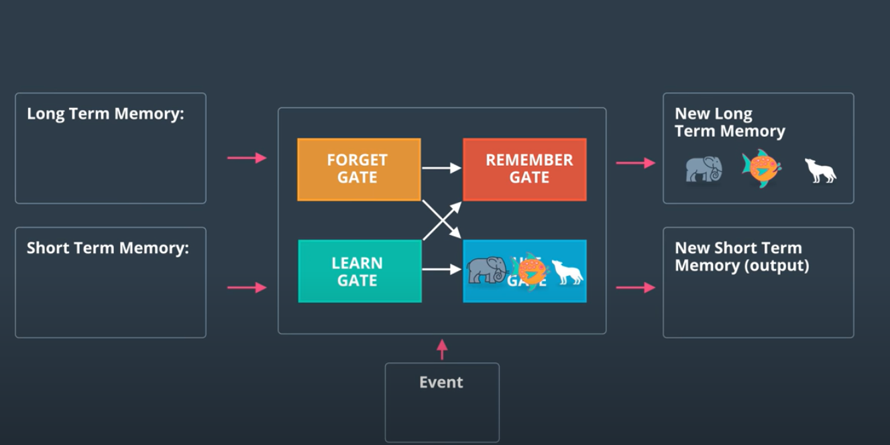

Step 4

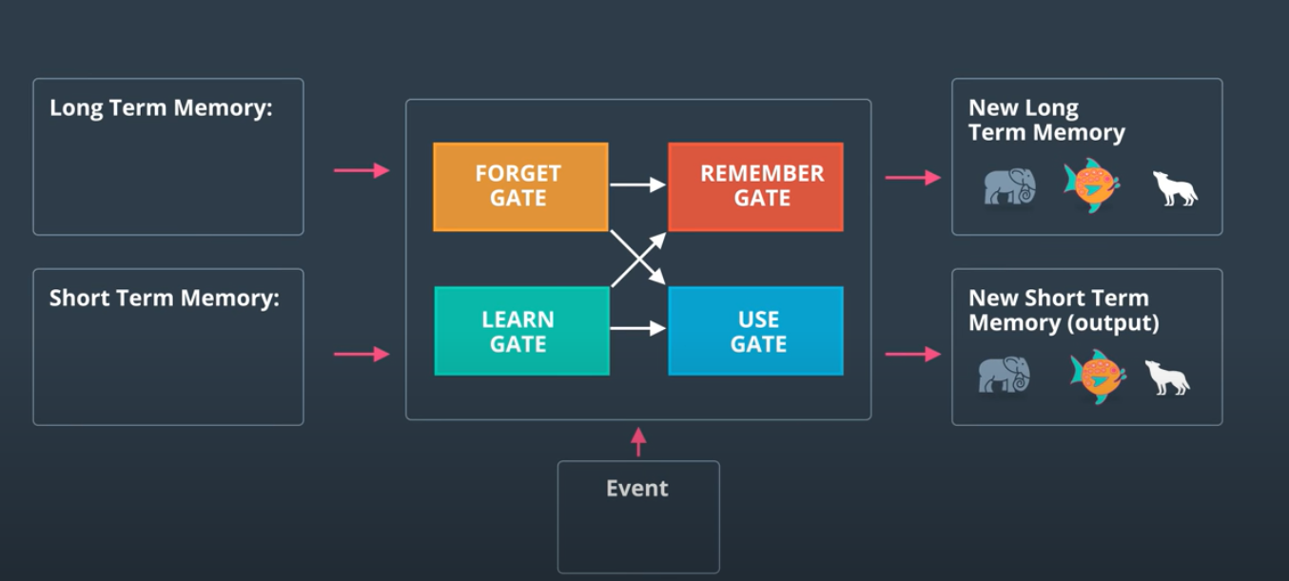

How does LSTM remember

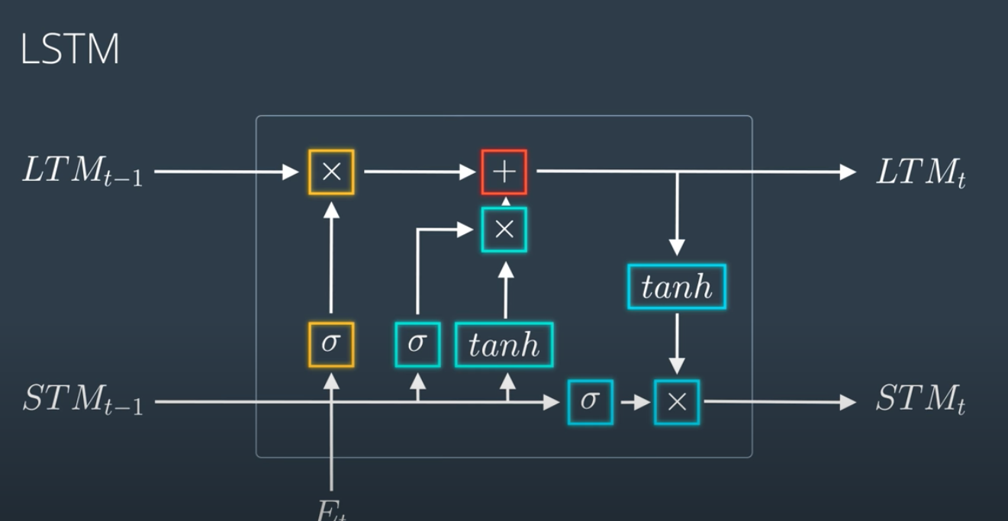

LEARN GATE

Step 1

Combines Short term momeory and Event to form a learn gate….

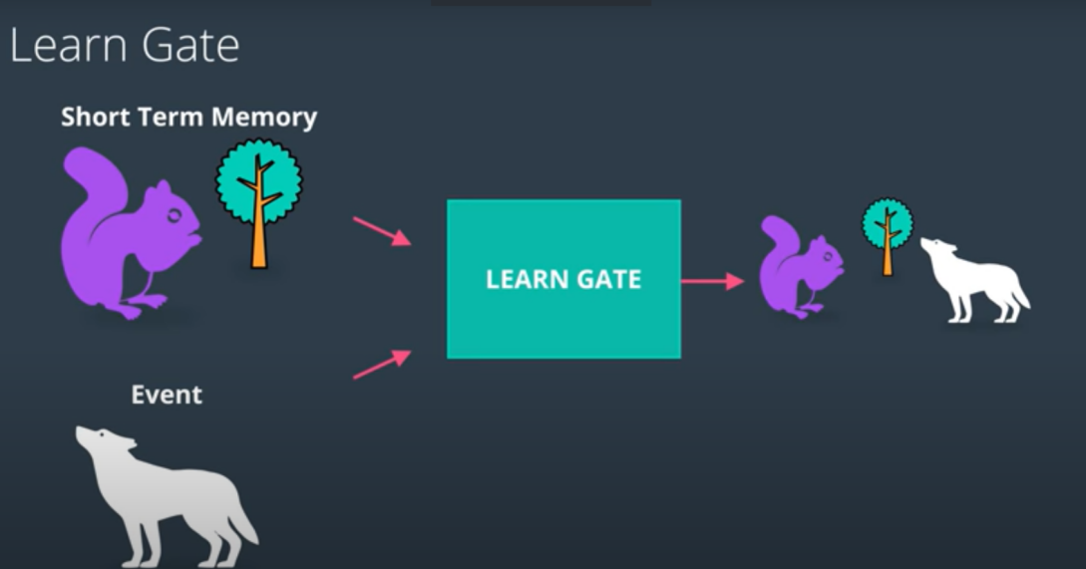

Actually it does a bit more .. ignores a bit from it

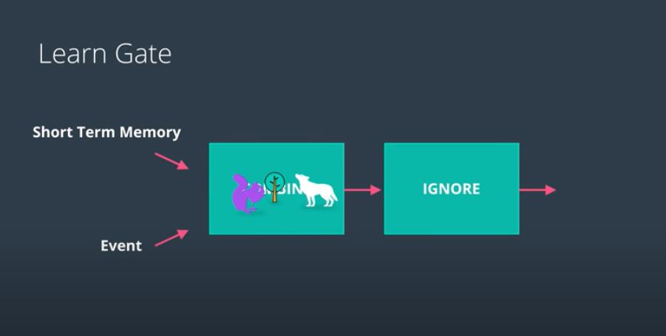

To summarize things mathematically

1. Step 1

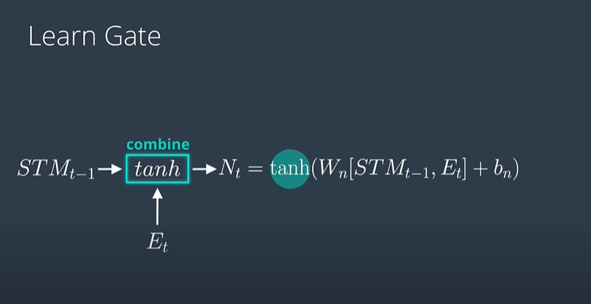

1. Step2 … theres always a ignore factor

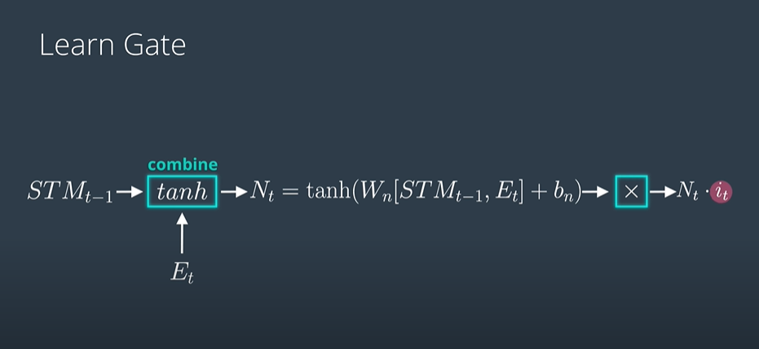

How is the ignore factor calculated:

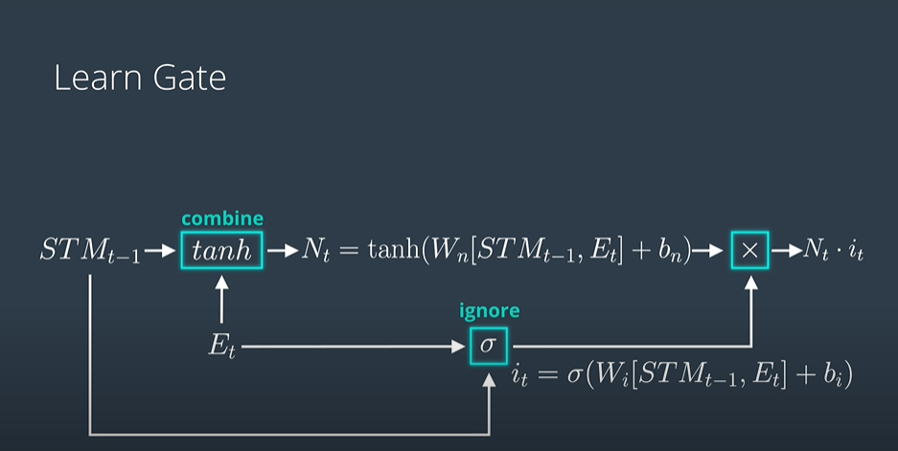

FORGET GATE

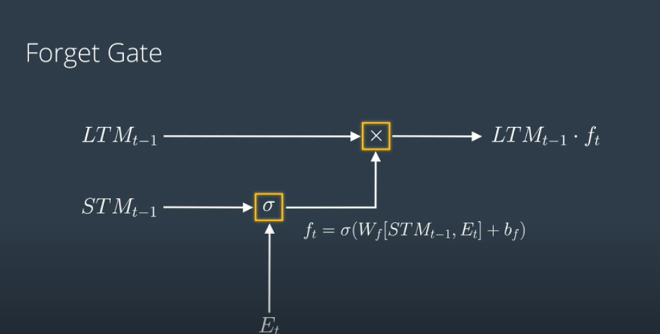

REMEMBER GATE - New Long term Memory

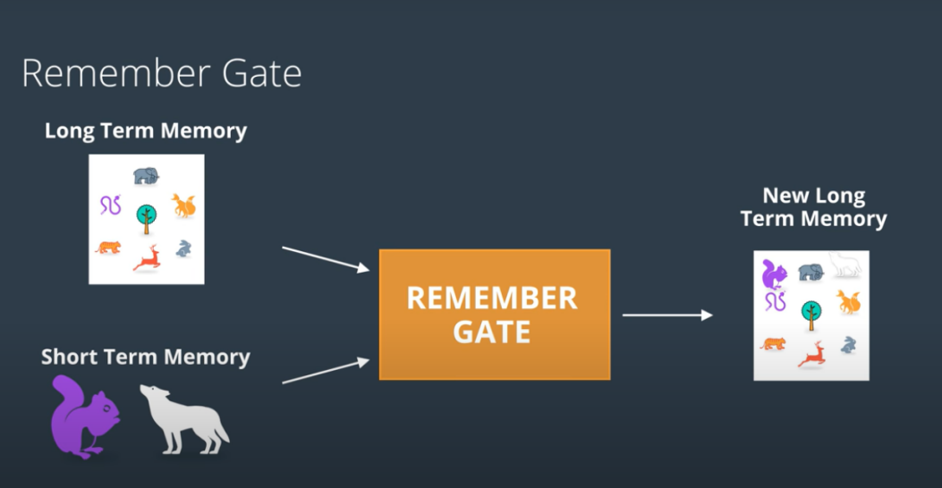

Mathematically

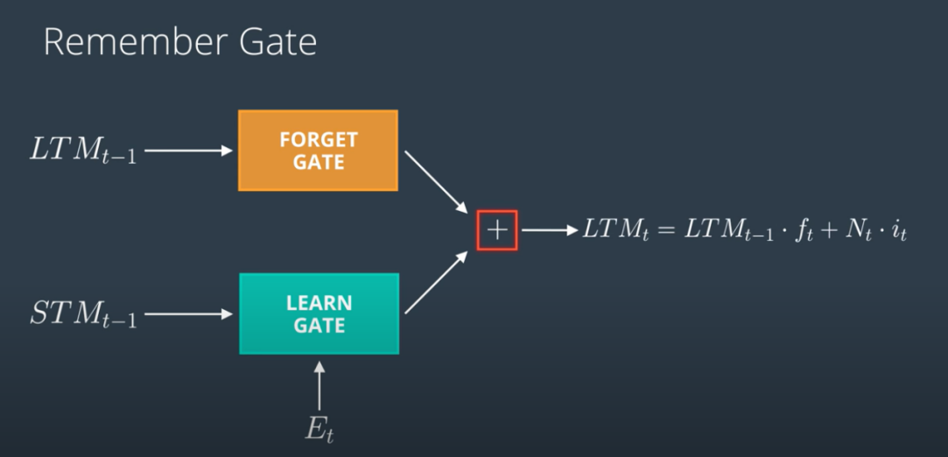

USE GATE - Keep whats useful from Long term and short term memor - New SHort term Memoryy

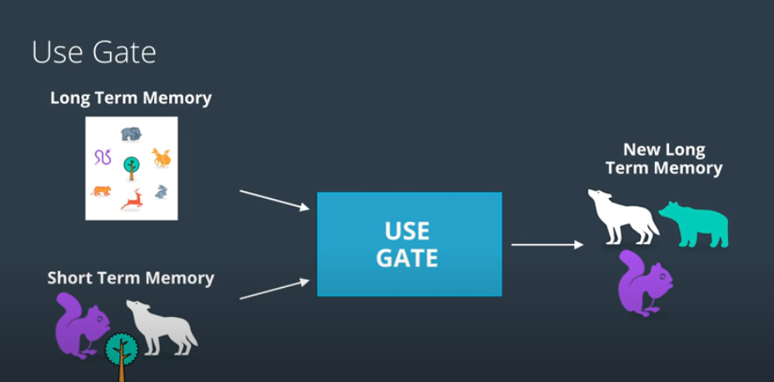

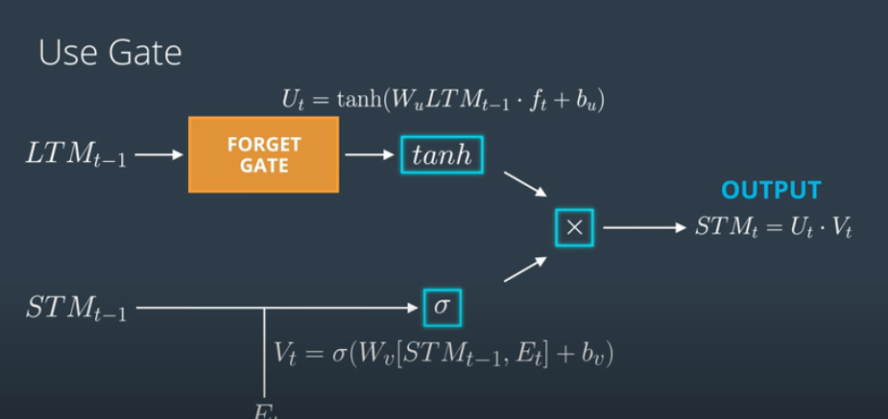

Putting it all together



# **CNN Long Short-Term Memory Networks**

The CNN Long Short-Term Memory Network or CNN LSTM for short is an LSTM architecture specifically designed for sequence prediction problems with spatial inputs, like images or videos.

## **CNN LSTM Architecture**

The CNN LSTM architecture involves using Convolutional Neural Network (CNN) layers for feature extraction on input data combined with LSTMs to support sequence prediction.

CNN LSTMs were developed for visual time series prediction problems and the application of generating textual descriptions from sequences of images (e.g. videos). Specifically, the problems of:

* **Activity Recognition**: Generating a textual description of an activity demonstrated in a sequence of images.
* **Image Description**: Generating a textual description of a single image.
* **Video Description**: Generating a textual description of a sequence of images.

This architecture was originally referred to as a Long-term Recurrent Convolutional Network or LRCN model, although we will use the more generic name “CNN LSTM” to refer to LSTMs that use a CNN as a front end in this lesson.

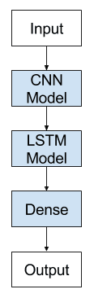

https://machinelearningmastery.com/how-to-develop-rnn-models-for-human-activity-recognition-time-series-classification/

<https://colab.research.google.com/drive/1NHKe1XkZzfUTWcEUxP_oZnO83Qza4SVK?usp=sharing#scrollTo=mp6mnPBfDFrg>

<https://keras.io/examples/vision/conv_lstm/>

RNN intends to capture temporal dependencies over time